VIBRATING SCREENS

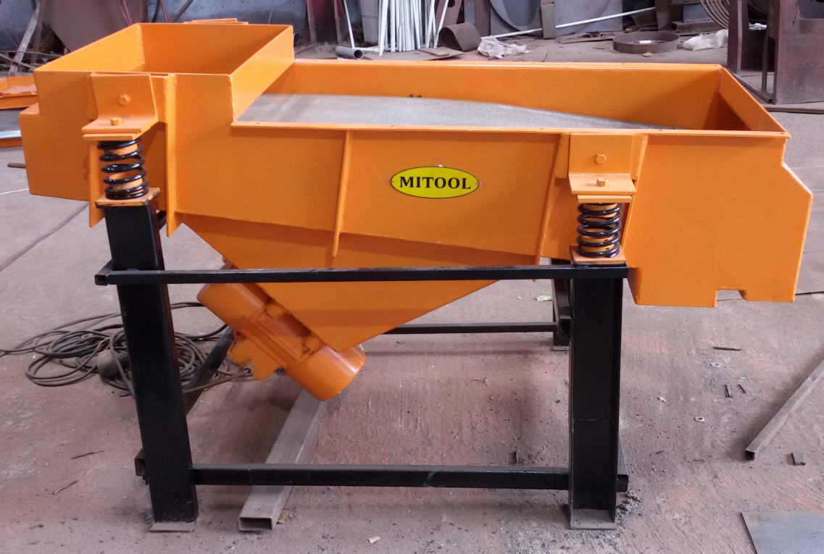
Vibrating Screens are extensively used in Iron & steel works, collieries, Quarries, mines, Chemical, pharmaceuticals, ceramics, Rubber, Clay & glass industries for handling all types of materials.
Mitool Make Linear motion rectangular vibrating screens are rugged & designed for long life. Mitool selects & delivers the most efficient & economical vibrating screen for individual application.
Screening performance is affected by various characteristic of feed material including particle size shape, Bulk density, flow ability, moisture , methods of loading etc. Most important is the particle size distribution of the feed material.
Mitool Make Linear motion rectangular vibrating screens are operated by a two unbalance motors which produces liner vibrations. Linear motion screens are very high performance machines, in terns of capacity & efficiency. They have a low inclination which varies between 0-15 degree down slope. Mitool vibratory screen are supported by suitable springs which isolate the vibration.
Mitool also make grizzly bar vibrating screens to extract coarse material from storage bins or storage hoppers & convey it to downstream crushers.
OUR OTHER PRODUCTS
1) Vibrating Furnace Charger
2) De watering Vibrating screen
3) Tubular motorized Vibrating Feeder
4) Motorised through Vibrating Feeder
5) Magnetic Vibrating Feeder

ELECTROMAGNETIC VIBRATING FEEDER

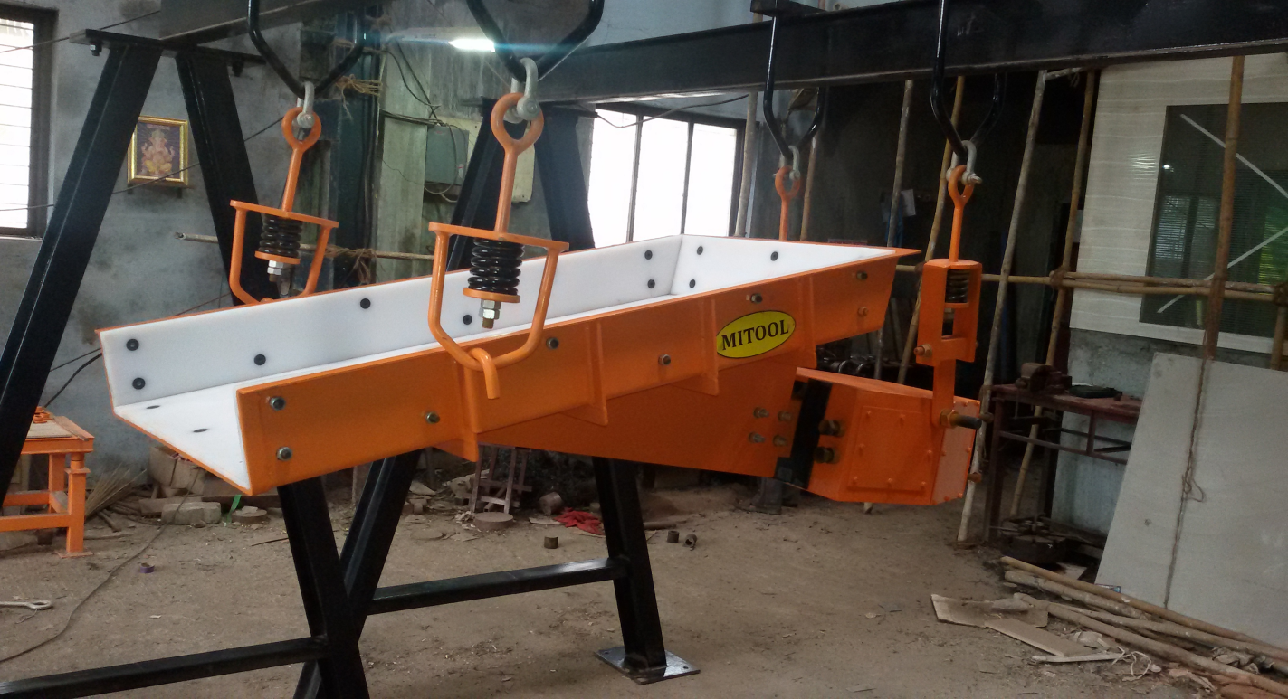

Mitool Make Vibrating feeders are most efficient & economical to convey the bulk materials & in the simplest easiest means of controlling the flow rate.
The Vibrating feeders are extensively used in mines, chemicals, ceramic, Rubber, Pharmaceuticals, clay, Iron & steel Industries, collieries, Quarries of glass industries for handling of all type of materials capacities from 1 Ton to 400 Tones per hour.
Vibrating Feeders are operated by giving pulsating D.C. supply. When this pulsating supply passed through starter creates a series of interrupted pulls on the Armature. 3000 pulse (Vibration) are occurring in one minute.
The Vibrating feeder consists of vibrating trough fitted to the drive unit of considerable weights
The electromagnet unit is mounted inside a heavy housing unit, The power unit which is mounted inside the housing houses the spring bars (Flats) which consisting of a number of leaf springs clamped at the two ends of the power unit.
A heavy fabricated centre piece carries the magnet armature at one end & vib feeder trough at other end. The centre clamp tightens at the middle of the spring bar system .
Stiffeners & gussets are provided to make the trough rigid. Our Feeders Protects the belt conveyors from damage by feeding the material on to the belt conveyors from storage hoppers, silos, surge hoppers & dumpers at the controlled rate. In magnetic feeders there are no wearing mechanical parts, such as gears, cams, belt, bearing, eccentrics weights or motors.
Mitool Vibratory feeders are most economical equipments.

